Me llamo __________________________ Tarea __________

Florida

1. Capital: ______________ 2. Nickname: _______________

3. Population: _______________

4. On the map, label Tallahassee, Miami, Tampa, Jacksonville, the Gulf of Mexico,
the Atlantic Ocean and Cuba.
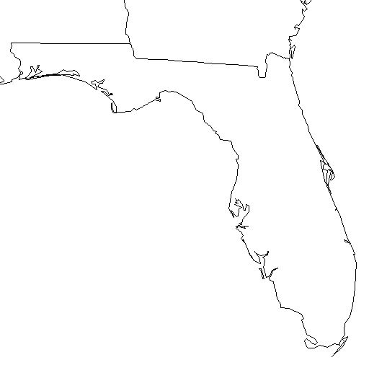

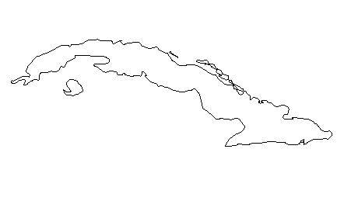

5. The Port of Miami is the busiest ____________________ port in the world.

6. ______ of the cargo from Latin America and the Caribbean comes through the
Port of Miami.

7. _____ out of ______ people in Miami are Latino.

8. _____ of the Latino population is ________________.

